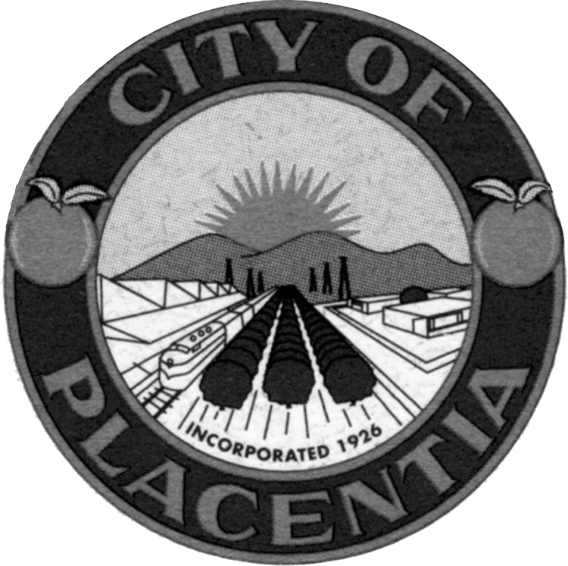  Kenny Binnings  Chair  Patti Martin  Vice Chair  Carole Nixon  Treasurer  Frank Perez  Janice Lacher  Vacant  Vacant  City of Placentia  401 E Chapman Avenue  City of Placentia, CA 92870  Community Services Department  Phone: (714) 993-8184  Fax: (714) 961-0283  Website: www.placentia.org | Heritage Festival Committee  Agenda  July 10, 2019 – 6:30 p.m.  Regular Meeting  Heritage Festival Committee  Procedures for Addressing the Heritage Festival Committee  Any person who wishes to speak regarding an item on the agenda or on a subject within the City’s jurisdiction during the “Oral Communications” portion of the agenda should fill out a “Speaker Request Form” and give it to the recording secretary BEFORE that portion of the agenda is called.  The Heritage Festival Committee encourages free expression of all points of view. To allow all persons the opportunity to speak, please keep your remarks brief. If others have already expressed your position, you may simply indicate that you agree with a previous speaker. If appropriate, a spokesperson may present the views of an entire group. To encourage all views, Heritage Festival Committee discourage clapping, booing or shouts of approval or disagreement from the audience.  PLEASE SILENCE ALL PAGERS, CELL PHONES, AND OTHER ELECTRONIC EQUIPMENT WHILE COMMITTEE IS IN SESSION.  Special Accommodations  In compliance with the Americans with Disabilities Act, if you need special assistance to participate in this meeting, please contact the Community Services Department at (714) 993-8184. Notification 48 hours prior to the meeting will generally enable City staff to make reasonable arrangements to ensure accessibility.  (28 CFR 35.102.35.104 ADA Title II)  Copies of all agenda materials are available for public review in the Office of the City Clerk. Persons who have questions concerning any agenda item may call the Community Services Department, (714) 993-8184, to make inquiry concerning the nature of the item described on the agenda.  In compliance with Senate Bill 343, any writings or documents provided to a majority of the City Council regarding any item on this agenda that are not exempt from disclosure under the Public Records Act will be made available for public inspection at the City Clerk’s Office at City Hall, 401 East Chapman Avenue, Placentia, during normal business hours.

REGULAR MEETING
July 10, 2019, 6:30 p.m. – Placentia City Hall

MEETING CALLED TO ORDER

PLEDGE OF ALLEGIANCE

EXECUTIVE COMMITTEE

ROLL CALL: Chair / Kenny Binnings

Vice Chair / Patti Martin
Treasurer / Carole Nixon
Frank Perez
Janice Lacher

ORAL COMMUNICATIONS

At this time, the public is invited to address the Heritage Festival Committee concerning any agenda item, which is not a public hearing item or other items under the jurisdiction of the Heritage Festival Committee.

COMMITTEE COMMENTS AND REPORTS
The purpose of these reports is to provide information on projects that are discussed at sub-committee meetings. No decisions are to be made on these issues. If a Committee member would like formal action on any of the discussed items, it will be placed on a future Agenda.

HERITAGE FESTIVAL COMMITTEE AGENDA

- Minutes
  - Adjourned Regular meeting
June 12, 2019
Recommended Action: Approve

- Treasurer’s Report – Carole Nixon to provide an updated treasurer’s report.
- Sub-Committee Reports – Committees to review and discuss the area of responsibility.
  - Band Review
  - Business Expo
  - Car Show
  - Craft
  - Food
  - Games/Activities
  - Home-Based
  - Non-Profit
  - Parade

- Update on Chip Reader Quotes – Committee and Staff to discuss chip reader quotes.

- Update on Parade Grand Marshall – Committee and Staff to discuss the status of the parade Grand Marshall.

- Volunteers – Committee and Staff to discuss volunteer search.

- Staff Comments – Staff to provide updates and discuss areas of responsibilities.

- Agenda Building – Committee and Staff to review agenda items for the next meeting.

ADJOURNMENT
The Heritage Festival Committee Adjourn to the next regular meeting on Wednesday, August 14, 2019 at 6:30 p.m. in Administration Conference Room 1 located at City Hall, 401 East Chapman Avenue, Placentia.

CERTIFICATION OF POSTING
I, Aileen Munoz, Community Services Coordinator/Heritage Festival Staff Liaison, hereby certify that the Agenda for the July 10, 2019 meeting of the Heritage Festival Committee was posted on Wednesday, July 3, 2019.

________________________
Aileen Munoz
Community Services Coordinator/Heritage Festival Committee Staff Liaison

