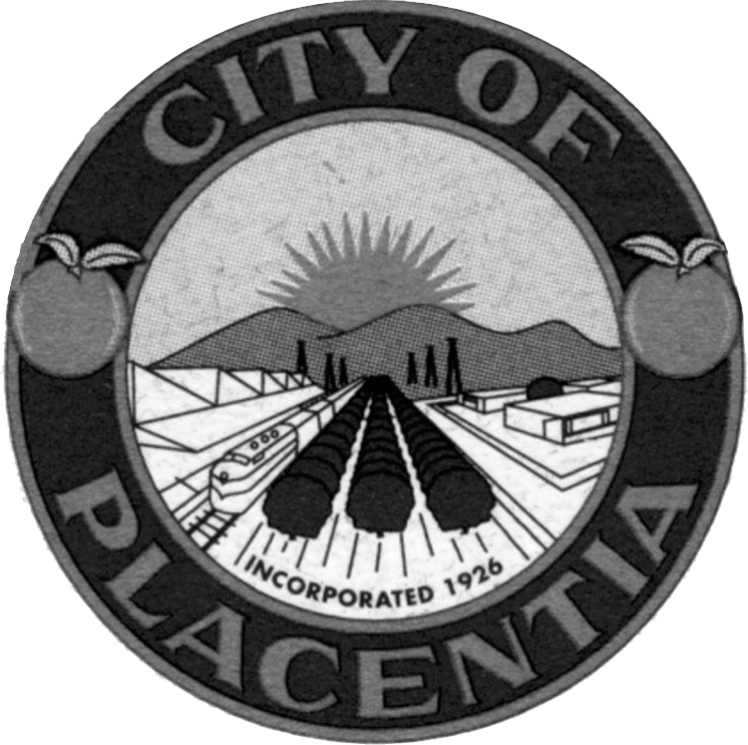  Chair  Tricia Montelongo  Vice Chair  Manpreet Chadha  Virginia Marinez  Aida Ohsner  Marie Wabeh  Jodi Stout Ward  Vacant  City of Placentia  401 E Chapman Avenue  City of Placentia, CA 92870  Community Services Department  Phone: (714) 993-8232  Fax: (714) 961-0283  Website: www.placentia.org | Senior Advisory Committee  Agenda  September 10, 2025, 6:15 p.m.  Placentia Senior Center  Procedures for Addressing the Senior Advisory Committee  Any person who wishes to speak regarding an item on the agenda or on a subject within the City’s jurisdiction during the “Oral Communications” portion of the agenda should fill out a “Speaker Request Form” and give it to the recording secretary BEFORE that portion of the agenda is called.  The Senior Advisory Committee encourages free expression of all points of view. To allow all persons the opportunity to speak, please keep your remarks brief. If others have already expressed your position, you may simply indicate that you agree with a previous speaker. If appropriate, a spokesperson may present the views of an entire group. To encourage all views, Senior Advisory Committee discourage clapping, booing or shouts of approval or disagreement from the audience.  PLEASE SILENCE ALL PAGERS, CELL PHONES, AND OTHER ELECTRONIC EQUIPMENT WHILE COMMITTEE IS IN SESSION.  Special Accommodations  In compliance with the Americans with Disabilities Act, if you need special assistance to participate in this meeting, please contact the Community Services Department at (714) 993-8232. Notification 48 hours prior to the meeting will generally enable City staff to make reasonable arrangements to ensure accessibility.  (28 CFR 35.102.35.104 ADA Title II)  Copies of all agenda materials are available for public review in the Office of the City Clerk. Persons who have questions concerning any agenda item may call the Community Services Department at (714) 993-8232 to make inquiry concerning the nature of the item described on the agenda.  In compliance with Senate Bill 343, any writings or documents provided to a majority of the Senior Advisory Committee regarding any item on this agenda that are not exempt from disclosure under the Public Records Act will be made available for public inspection at the City Clerk’s Office at City Hall, 401 East Chapman Avenue, Placentia, during normal business hours.

Senior Advisory Committee
Regular Meeting

September 10, 2025, 6:15 P.M. – Placentia Senior Center

MEETING CALLED TO ORDER

ROLL CALL: Tricia Montelongo
Manpreet Chadha
Virginia Martinez
Aida Ohsner
Marie Wabeh
Jodi Sout Ward

PLEDGE OF ALLEGIANCE

ORAL COMMUNICATIONS

At this time the public is invited to address the Senior Advisory Committee concerning any agenda item, which is not a public hearing item, or other items under the jurisdiction of the Senior Advisory Committee.

SENIOR ADVISORY COMMITTEE AGENDA

- Minutes
- Adjourned Special meeting
July 9, 2025
Recommended action: Approve.

- Senior Center Programming – Staff to provide an update on various activities.

- Meals on Wheels Update – Staff to provide update on in person dining transition.

- Transportation – Staff to provide an update on the Transportation.

- Senior Groceries Update – Staff to update on in person distribution transition.

- PCF Grant – Staff to provide update on Placentia Community Foundation Grant.

- Agenda Building and Meeting Schedule – Staff and Committee to review future agenda items.

- Committee Comments and Requests - Committee to contribute comments or requests regarding possible actions and services.

STAFF COMMENTS

ADJOURNMENT
The Senior Advisory Committee will adjourn to a Regular Meeting on Wednesday, November 12, 2025, at 6:15 p.m. at the Placentia Senior Center.

CERTIFICATION OF POSTING

I, Felipe Zambrano, Community Services Coordinator for the City of Placentia, hereby certify that the Agenda for the September 10, 2025, Regular Meeting of the Senior Advisory Committee was posted on Friday, September 5, 2025.

Felipe Zambrano
Felipe Zambrano
Community Services Coordinator

